**PEI Assessment**

***Findings and Areas of Concern***

- **Communication to Data Engineering Team,**

* Looks like all the Customers in the Customer base table haven’t placed the Order, It is possible considering Customer table as "Customer Master table" . Below are the Customer Examples whose details we don’t see in neither Shipping nor Orders Table.

|  |  |  |  |  |
| --- | --- | --- | --- | --- |
| Customer_ID | First | Last | Age | Country |
| 7 | David | Davis | 59 | USA |
| 16 | David | Benson | 61 | USA |
| 19 | James | Johnson | 67 | UK |
| 25 | Raymond | Taylor | 36 | UAE |

* There are a few customers who have placed the orders, but we don’t see the details in the Order detail table but directly in the shipping table, looks like we have missing data in the Orders table which needs a recheck. For example - below there are records of below customers in Shipping Details but not in Orders.

|  |  |  |  |  |
| --- | --- | --- | --- | --- |
| Customer_ID | First | Last | Age | Country |
| 1 | Joseph | Rice | 43 | USA |
| 2 | Gary | Moore | 71 | USA |
| 3 | John | Walker | 44 | UK |
| 6 | N!cole | Jones | 33 | USA |

* We also see that there are records in the Orders table for which we are missing shipment detail this needs a recheck too. Below are some examples.

|  |  |  |  |  |
| --- | --- | --- | --- | --- |
| Customer_ID | First | Last | Age | Country |
| 4 | Eric | Carter | 38 | UK |
| 5 | William | Jackson | 58 | UAE |
| 39 | Ruth | Smith | 50 | UK |
| 52 | Haley | Martinez | 75 | USA |
| 57 | Lacey | Mercado | 29 | USA |
| 59 | Amanda | Cohen | 72 | UK |
| 60 | Jeremy | Rodriguez | 28 | UAE |

* Looks like few customers have placed multiple Orders as each Item is considered as different Order_ID. This could have better divided into Order_ID and Order_line_item_ID (Product ID). So that if the Order is of a single Bucket that those could have given Single Order ID.

|  |  |  |  |
| --- | --- | --- | --- |
| Order_ID | Item | Amount | Customer_ID |
| 25 | Mousepad | 250 | 8 |
| 109 | DDR RAM | 1500 | 8 |
| 117 | Webcam | 350 | 8 |
| 158 | Mousepad | 200 | 8 |

Better Presentation would have been like the one below, considering 2 Orders placed on 2 different days and each order consist of 2 Products each which are unique

|  |  |  |  |  |  |
| --- | --- | --- | --- | --- | --- |
| Order_ID | Product ID | Item | Amount | Customer_ID | Order Date |
| 25 | 1 | Mousepad | 250 | 8 | 5/26/2024 |
| 25 | 2 | DDR RAM | 1500 | 8 | 5/26/2024 |
| 117 | 3 | Webcam | 350 | 8 | 5/27/2024 |
| 117 | 4 | Mousepad | 200 | 8 | 5/27/2024 |

* But looking at the Shipping Table as shipping table also as multiple shipping ID for unique Customers like below, there are chances that each item is considered as different Orders with different Order ID and Shipment ID.

|  |  |  |
| --- | --- | --- |
| Shipping_ID | Status | Customer_ID |
| 200 | Delivered | 8 |
| 210 | Delivered | 8 |

Order ID should be used as a foreign key or should be present in shipping table considering each line item has different Order ID in Orders table. So that Orders and shipping can be mapped Appropriately.

Communication to End user would look like below.

*We see some Discrepancy in the data and we are missing few customer order details and shipping details and our data Engineering team is working on it, While the team completes the Task, below is the Wireframe created using existing data*

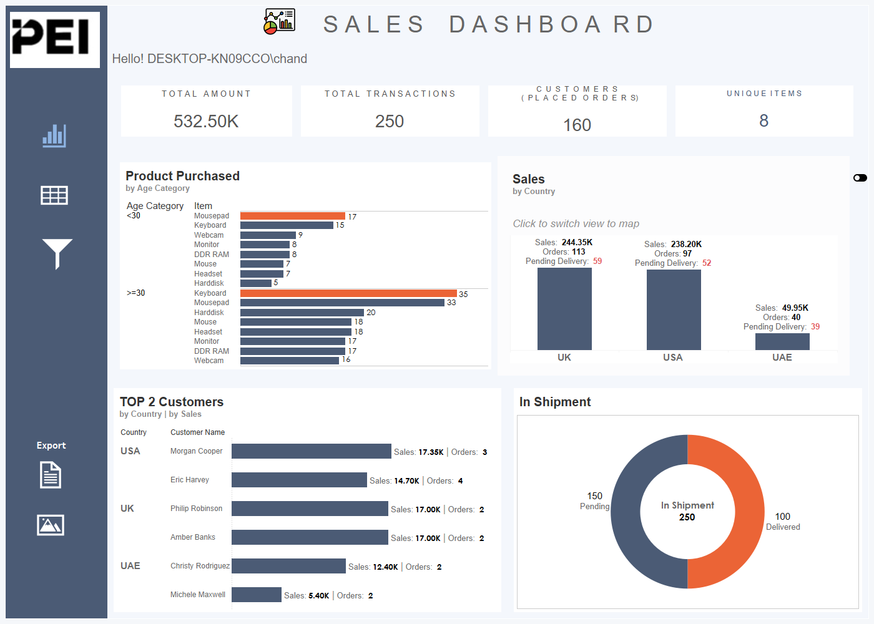

Few Insights as follows -

* Customers of Age below 30 are most interested in buying mouse whereas it is keyboard for age above 30! – This is may be because Customer of age above 30 already equipped with laptops and are buying external keyboards only. Whereas customers below 30 are more into Gaming and buying mouse as peripheral
* Looks like marketing is well established in UK and US and finding it’s way in UAE hence we see it’s least sales.
* Looks like 60% of total items are yet to be shipped which perhaps depicts that the Shipping has hurdles, and we may need to re-think on Supply chain management.

*We are looking for more appropriate and accurate data for more accurate insights and we are working with Data Engineering team continuously for better insights.*